Terraform-06
Execute the script shown in the video.
Terraform Module
A Terraform module is a group of Terraform configuration files that are used together to create and manage infrastructure.
In simple words:
A module is reusable Terraform code.
Instead of writing the same EC2 code again and again, we can put the EC2 code inside a module and reuse it whenever needed.
Terraform Module Structure
Let's create this structure:
terraform-module-demo
│
├── main.tf
├── variables.tf
│
└── ec2
├── main.tf
└── variables.tf
Child Module – ec2/main.tf
Inside:
ec2/main.tf
write:
resource "aws_instance" "server" {
ami = var.ami_id
instance_type = var.instance_type

tags = {
Name = var.instance_name
}
}
Notice that we are not hardcoding the AMI and instance type.
We are using variables:
var.ami_id
var.instance_type
var.instance_name
This makes the module reusable.

4. Child Module – ec2/variables.tf
Create:
ec2/variables.tf
Add:
variable "ami_id" {
type = string
}

variable "instance_type" {
type = string
}

variable "instance_name" {
type = string
}
Now the module expects three values:
ami_id
instance_type
instance_name
Root Module – main.tf
Now go to the root:
terraform-module-demo/main.tf
Add:
provider "aws" {
region = "us-east-1"
}

module "ec2" {
source = "./ec2"

ami_id = "ami-0332d564d76dbd8d6"
instance_type = "t3.micro"
instance_name = "my-module-ec2"
}
The important part is:
module "ec2" {
source = "./ec2"
}
This tells Terraform:
"Use the module located inside the ec2 directory."
How Variables Flow
This is an important concept.
In the root module: Root main.tf
provider "aws" {
region = "us-east-1"
}

module "ec2" {
source = "./ec2"

ami_id = "ami-0332d564d76dbd8d6"
instance_type = "t3.micro"
instance_name = "my-module-ec2"
}
Child ec2/main.tf
resource "aws_instance" "server" {
ami = var.ami_id
instance_type = var.instance_type

tags = {
Name = var.instance_name
}
}
Child ec2/variables.tf
variable "ami_id" {
type = string
}

variable "instance_type" {
type = string
}

variable "instance_name" {
type = string
}
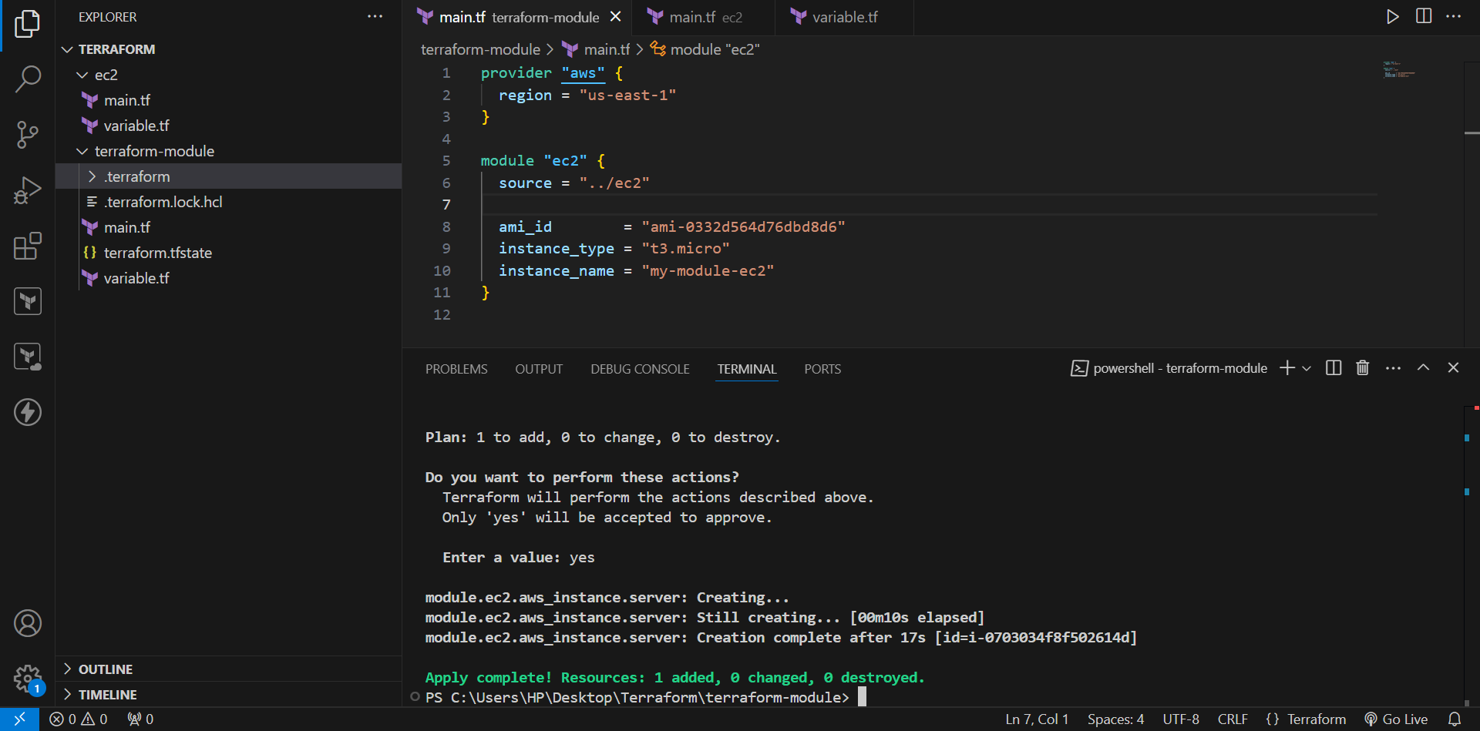
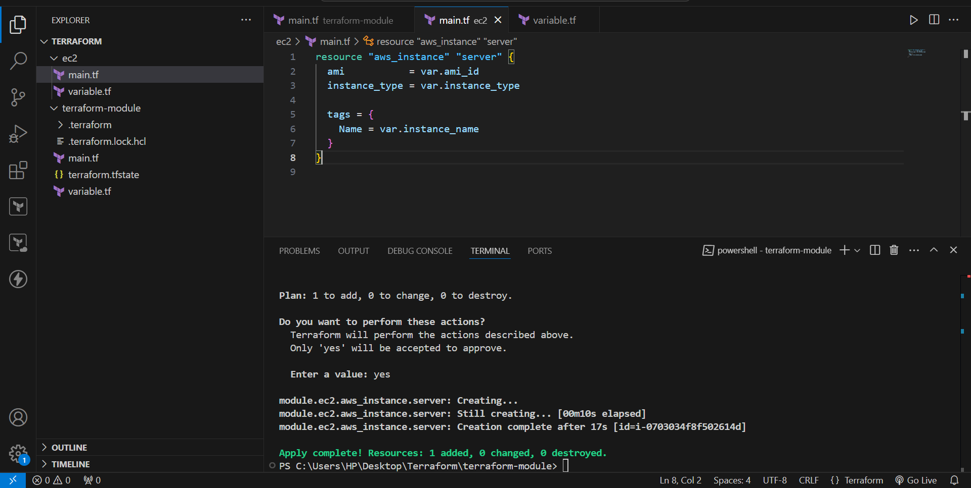
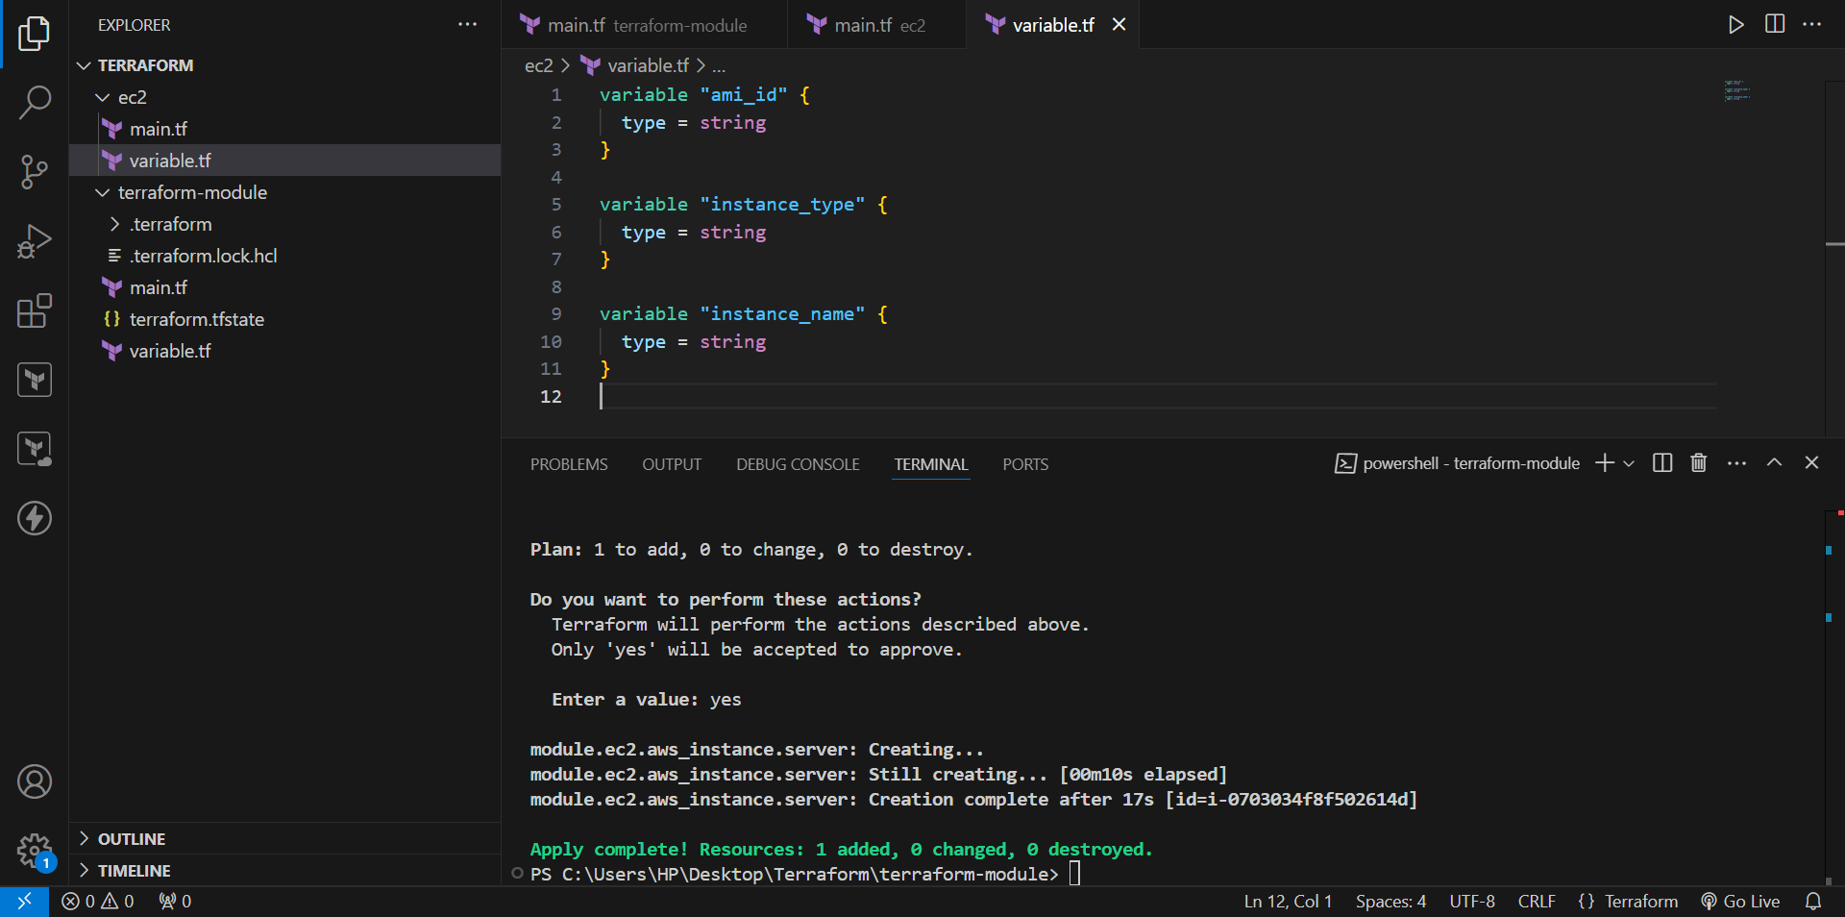
Run Terraform
Go to the root module:
cd C:\Users\HP\Desktop\Terraform\terraform-module-demo
Run:
terraform init
Terraform will detect the local module.
Then:
terraform validate
Then:
terraform plan
You should see something similar to:
Plan: 1 to add, 0 to change, 0 to destroy.
Finally:
terraform apply
Enter:
yes
Terraform creates:
my-module-ec2

module "ec2" {
source = "./ec2"

ami_id = "ami-0332d564d76dbd8d6"
instance_type = "t3.micro"
instance_name = "my-module-ec2"
}
We pass values to the child module.
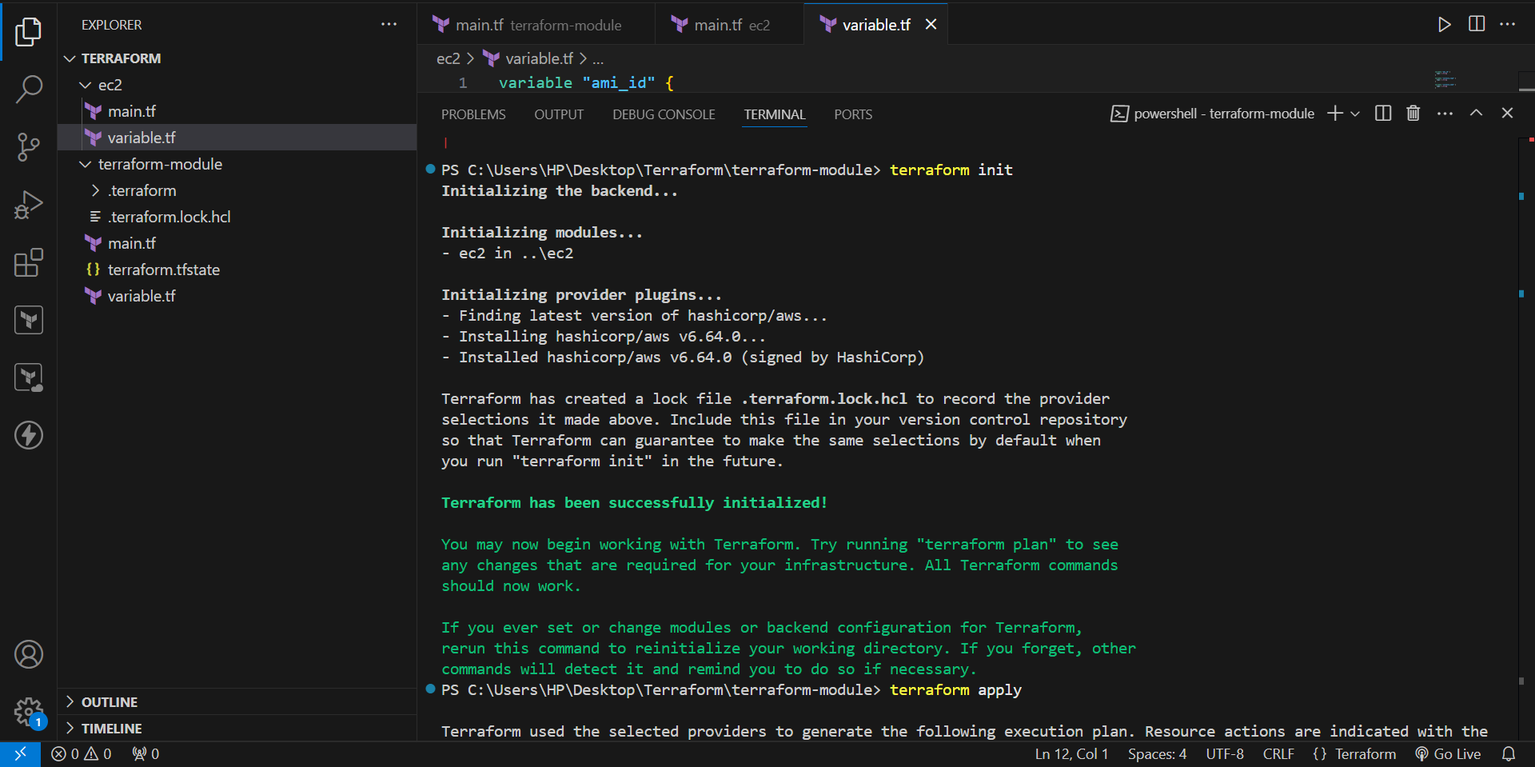
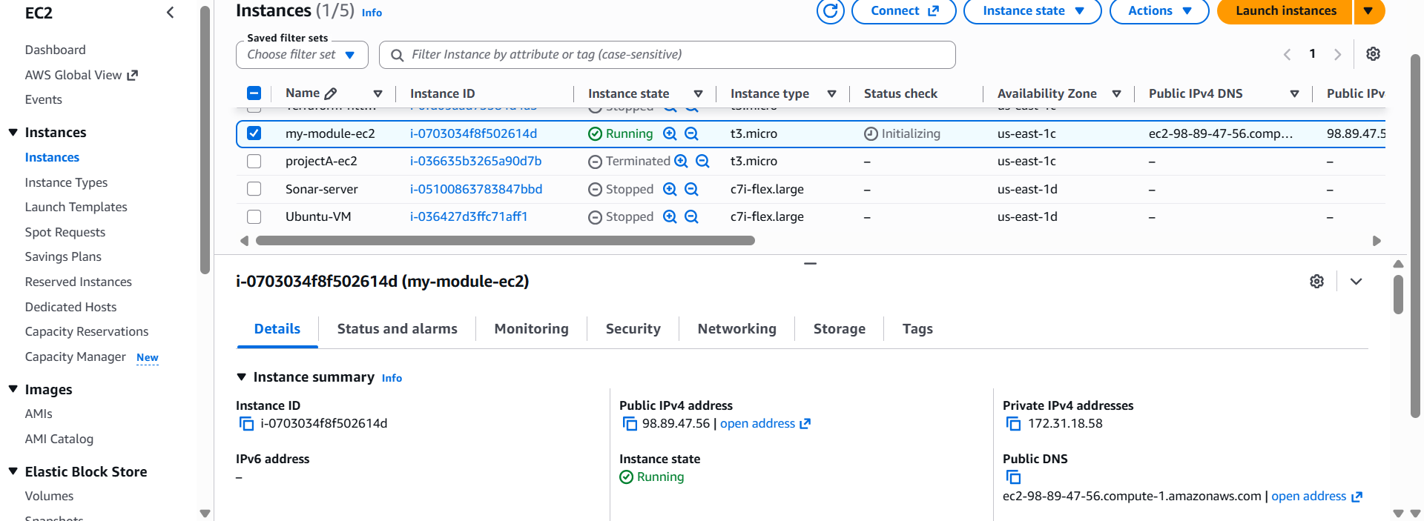
Terraform Workspaces
Create an EC2 instance using Terraform.
Use a map variable to store the AMI ID.
Create multiple Terraform workspaces such as dev, staging, and prod.
Use terraform.workspace to identify the currently selected environment.
Maintain separate Terraform state for each workspace.
Terraform Sample Code
The sample code is:
provider "aws" {
region = "us-east-1"
}

resource "aws_instance" "webserver" {
ami = var.ami["projectA"]
instance_type = "t3.micro"

tags = {
Name = "${terraform.workspace}-ec2"
}
}

variable "ami" {
type = map(any)

default = {
projectA = "ami-0332d564d76dbd8d6"
}
}
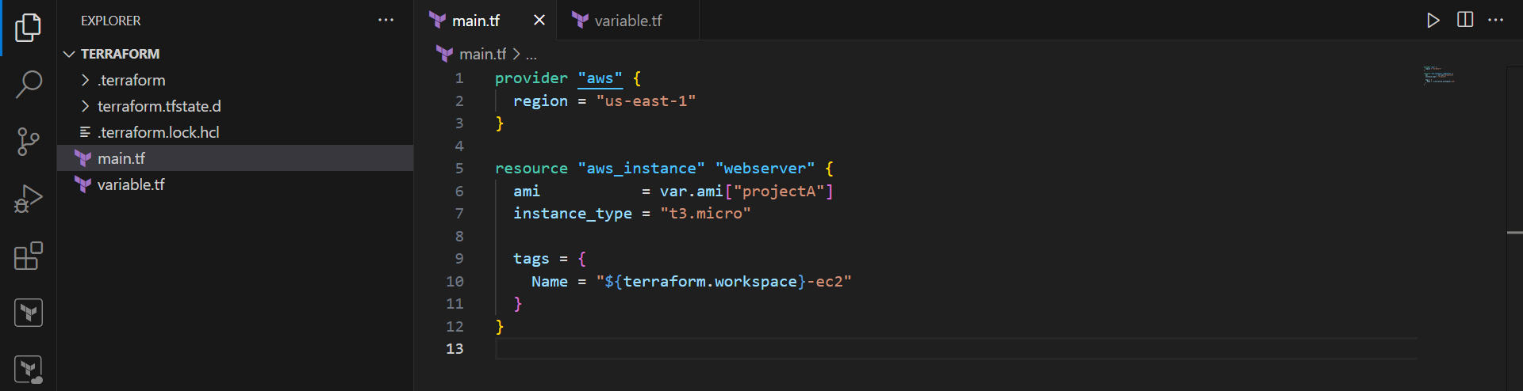
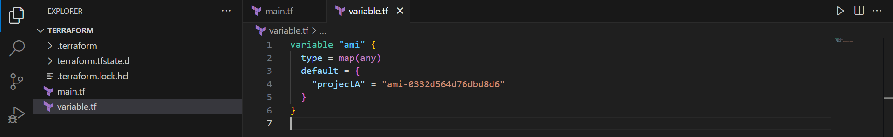
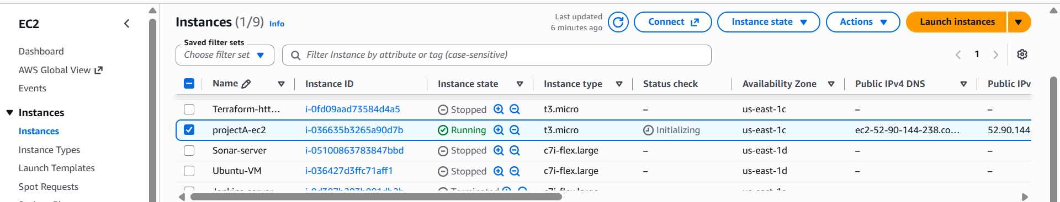

Provision EC2, S3, and VPC using Terraform modules.
Create the Project Directory
Open PowerShell and create the project directory.
mkdir C:\Users\HP\Desktop\Terraform
cd C:\Users\HP\Desktop\Terraform
Create the root module:
mkdir aws_instance
cd aws_instance
Create the child module directories:
mkdir ec2
mkdir s3
mkdir vpc
Final structure:
C:\Users\HP\Desktop\Terraform
└── aws_instance
├── main.tf
├── ec2
├── s3
└── vpc
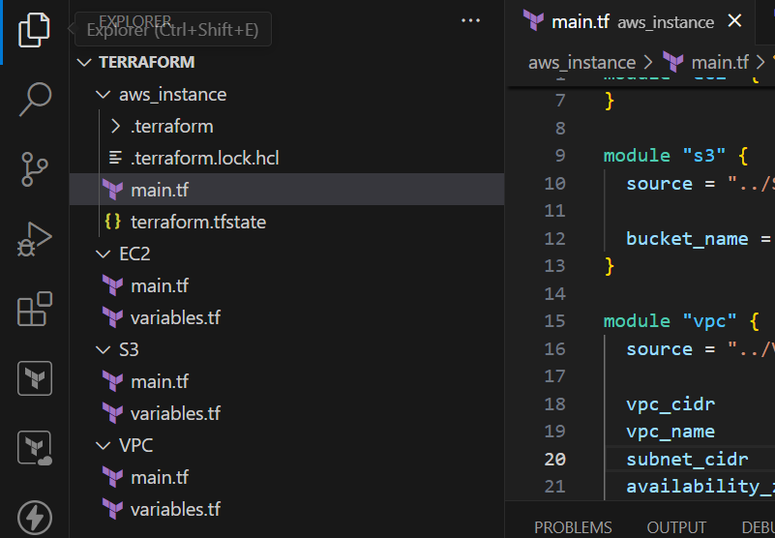
Create the EC2 Child Module
Go to the EC2 directory:
cd C:\Users\HP\Desktop\Terraform\aws_instance\ec2
Create:
main.tf
variables.tf
ec2/main.tf
resource "aws_instance" "this" {
ami = var.ami_id
instance_type = var.instance_type

tags = {
Name = var.instance_name
}
}
ec2/variables.tf
variable "ami_id" {
type = string
}
variable "instance_type" {
type = string
}
variable "instance_name" {
type = string
}
This module is responsible for creating the EC2 instance.
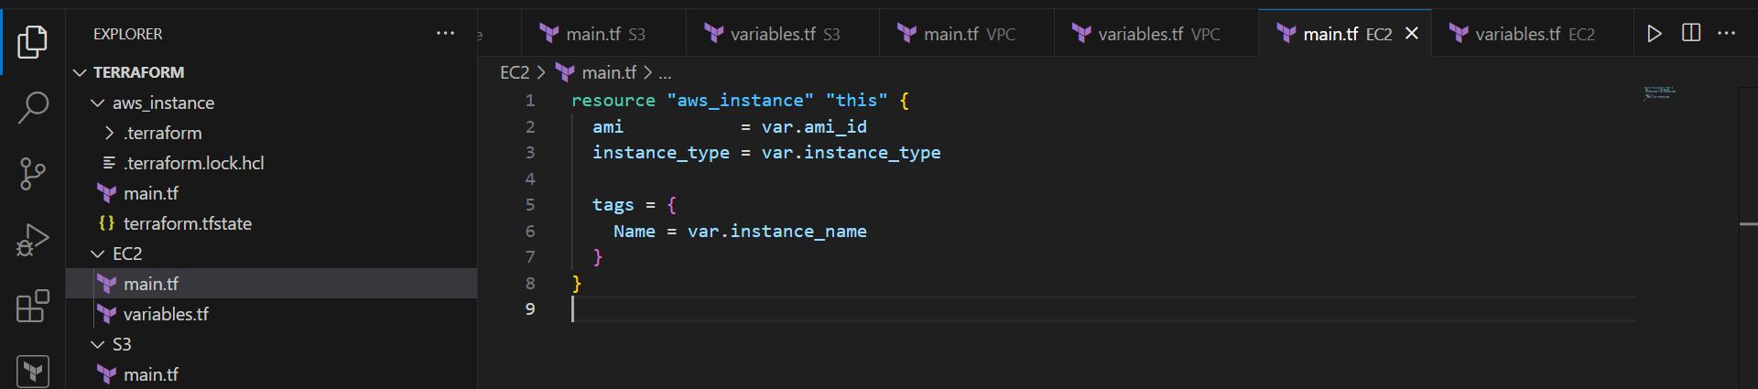
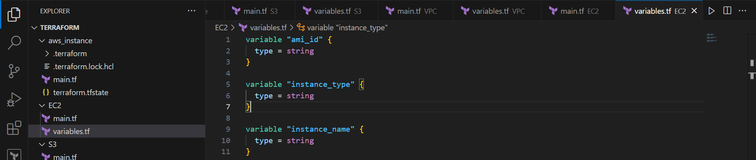
Create the S3 Child Module
Go to the S3 directory:
cd ..\s3
Create:
main.tf
variables.tf
s3/main.tf
resource "aws_s3_bucket" "this" {
bucket = var.bucket_name

tags = {
Name = var.bucket_name
}
}
s3/variables.tf
variable "bucket_name" {
type = string
}
This module is responsible for creating the S3 bucket.
Make sure the bucket name is globally unique across AWS.
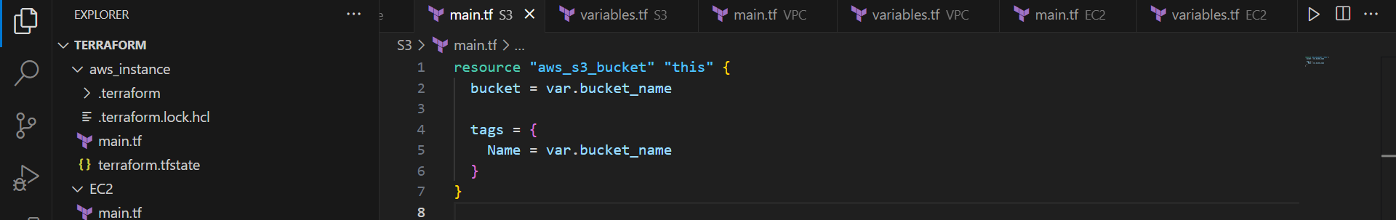
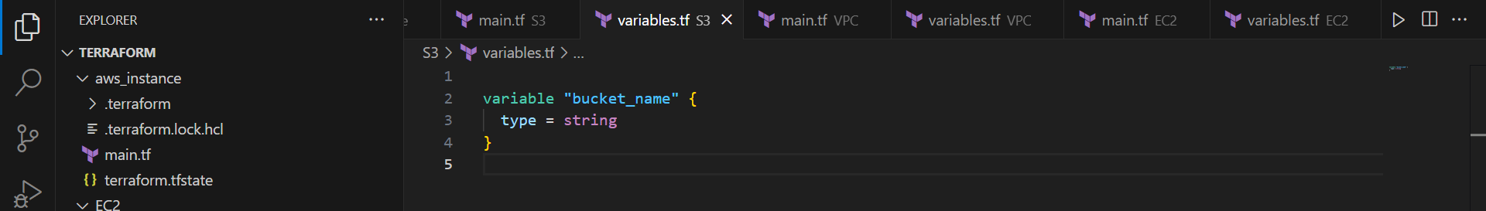
Create the VPC Child Module
Go to the VPC directory:
cd ..\vpc
Create:
main.tf
variables.tf
vpc/main.tf
resource "aws_vpc" "this" {
cidr_block = var.vpc_cidr

tags = {
Name = var.vpc_name
}
}

resource "aws_subnet" "public" {
vpc_id = aws_vpc.this.id
cidr_block = var.subnet_cidr
availability_zone = var.availability_zone
map_public_ip_on_launch = true

tags = {
Name = "public-subnet"
}
}

resource "aws_internet_gateway" "this" {
vpc_id = aws_vpc.this.id

tags = {
Name = "terraform-igw"
}
}

resource "aws_route_table" "public" {
vpc_id = aws_vpc.this.id

route {
cidr_block = "0.0.0.0/0"
gateway_id = aws_internet_gateway.this.id
}

tags = {
Name = "public-route-table"
}
}

resource "aws_route_table_association" "public" {
subnet_id = aws_subnet.public.id
route_table_id = aws_route_table.public.id
}
vpc/variables.tf
variable "vpc_cidr" {
type = string
}

variable "vpc_name" {
type = string
}

variable "subnet_cidr" {
type = string
}

variable "availability_zone" {
type = string
}
This module creates:
- VPC
- Public subnet
- Internet Gateway
- Route table
- Route table association
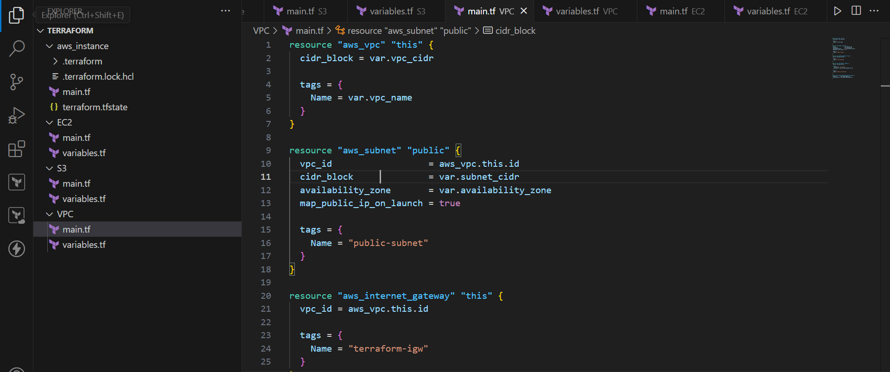
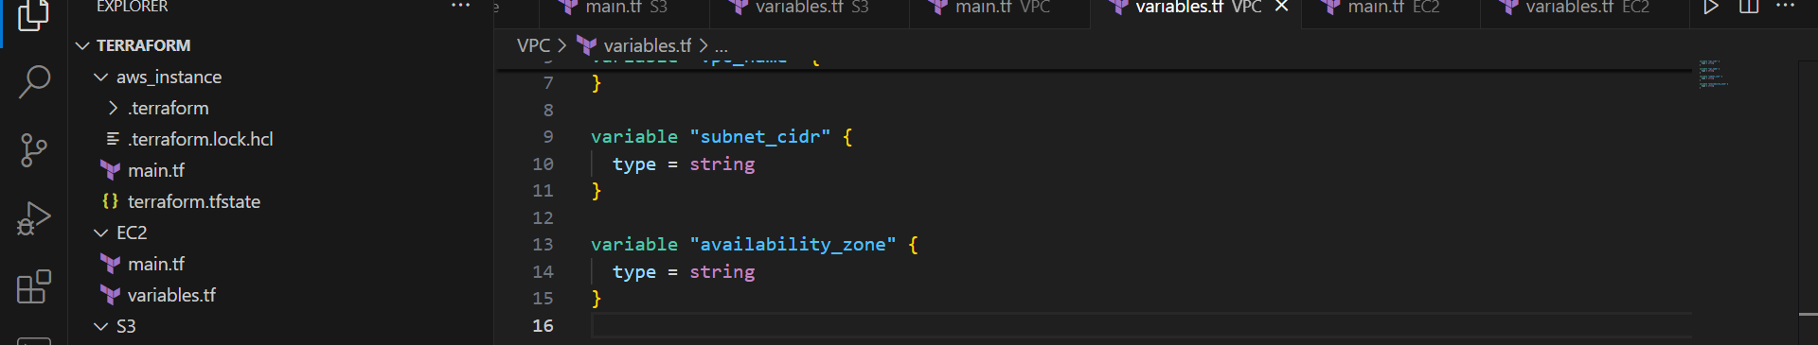
Create the Root Module
Go back to the root directory:
cd C:\Users\HP\Desktop\Terraform\aws_instance
Create:
main.tf
The root module will call the three child modules.
aws_instance/main.tf
provider "aws" {
region = "us-east-1"
}

module "ec2" {
source = "./ec2"

ami_id = "ami-0332d564d76dbd8d6"
instance_type = "t3.micro"
instance_name = "my-terraform-ec2"
}

module "s3" {
source = "./s3"

bucket_name = "my-terraform-s3-bucket-123456789"
}

module "vpc" {
source = "./vpc"

vpc_cidr = "10.0.0.0/16"
vpc_name = "my-terraform-vpc"
subnet_cidr = "10.0.1.0/24"
availability_zone = "us-east-1a"
}
Change the S3 bucket name if necessary because S3 bucket names must be globally unique.
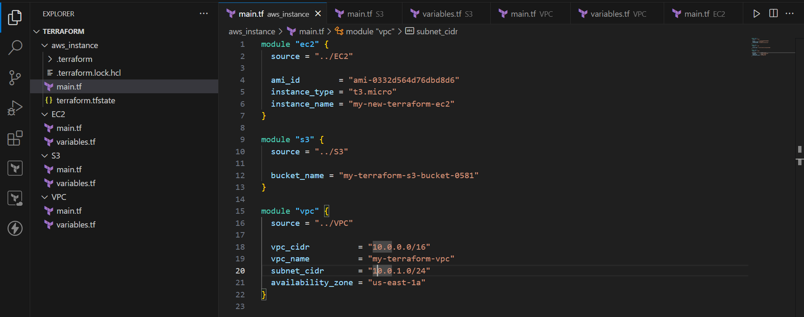
Understand the Module Source Paths
In the root module:
source = "./ec2"
means:
aws_instance/
└── ec2/
Similarly:
source = "./s3"
means:
aws_instance/
└── s3/
And:
source = "./vpc"
means:
aws_instance/
└── vpc/
The ./ means current directory.
Initialize Terraform
Make sure you are inside the root module:
cd C:\Users\HP\Desktop\Terraform\aws_instance
Run:
terraform init
Terraform will initialize the project and load the child modules and AWS provider.
You should see a message similar to:
Terraform has been successfully initialized!
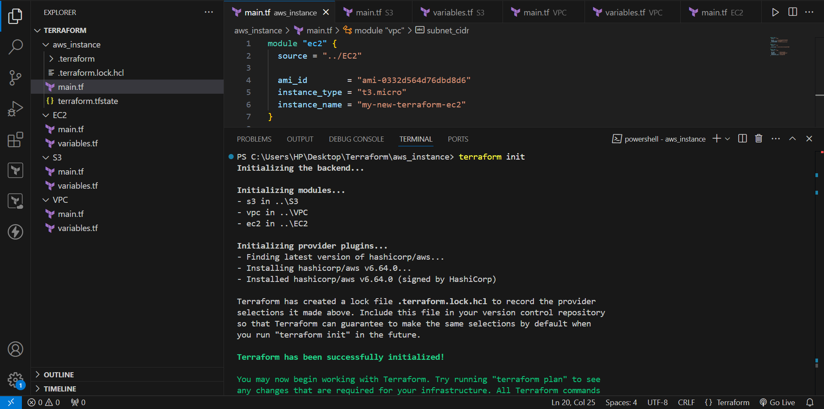
Validate the Configuration
Run:
terraform validate
Expected result:
Success! The configuration is valid.
terraform validate checks whether the Terraform configuration is syntactically and structurally valid.
It does not create AWS resources.
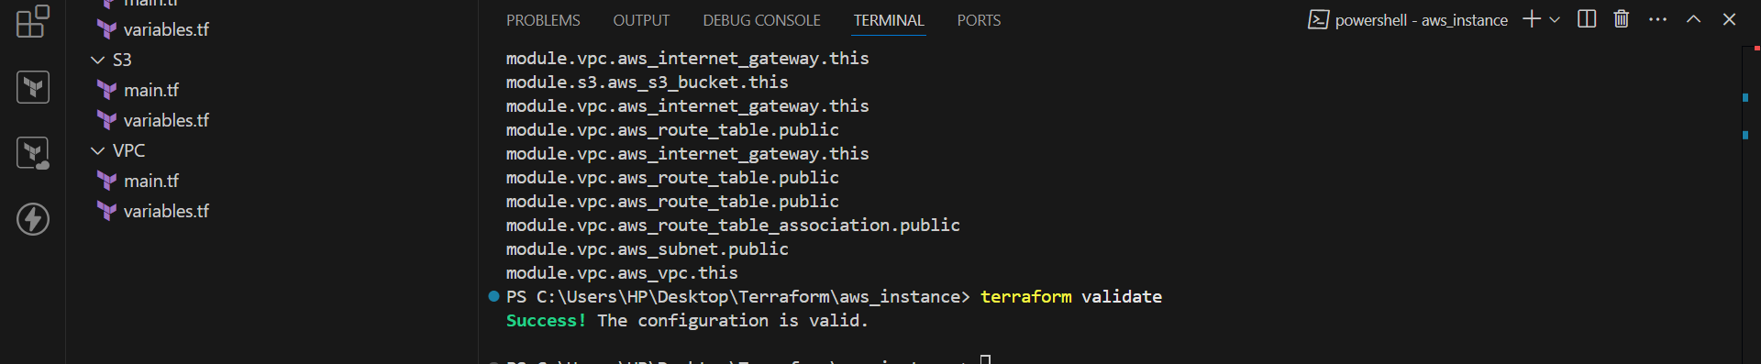
Verify the Resources
After successful execution, verify the resources in the AWS Console.
EC2
Go to:
AWS Console → EC2 → Instances
You should see:
my-terraform-ec2
S3
Go to:
AWS Console → S3 → Buckets
You should see your Terraform-created bucket.
VPC
Go to:
AWS Console → VPC → Your VPCs
You should see:
my-terraform-vpc
You can also verify the subnet, Internet Gateway, and route table.
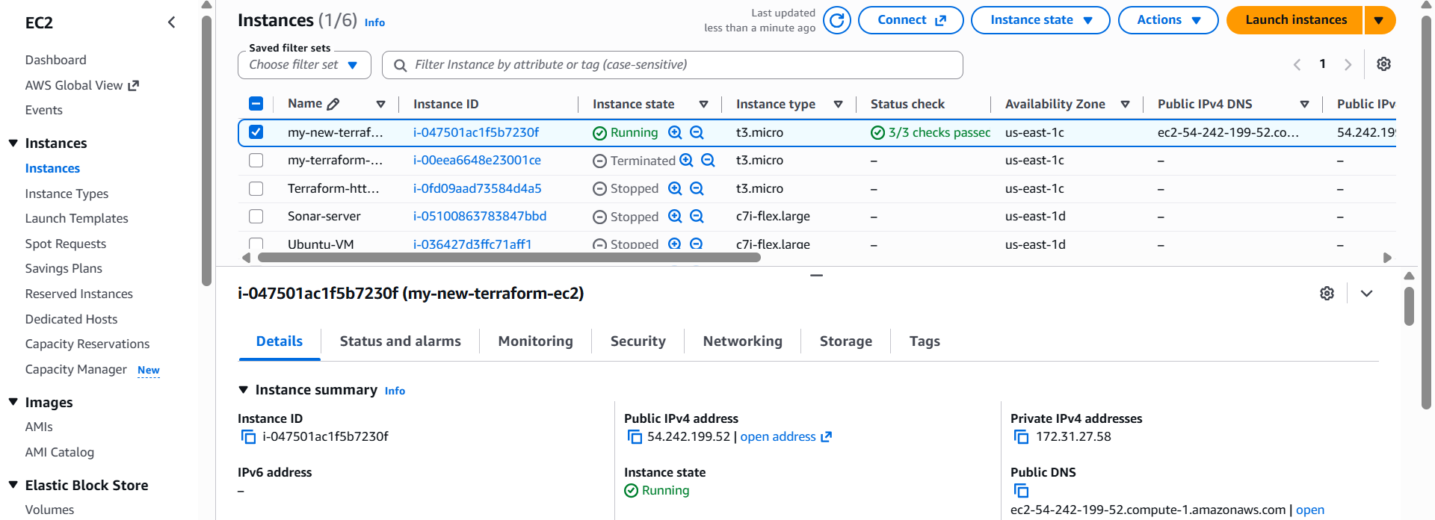
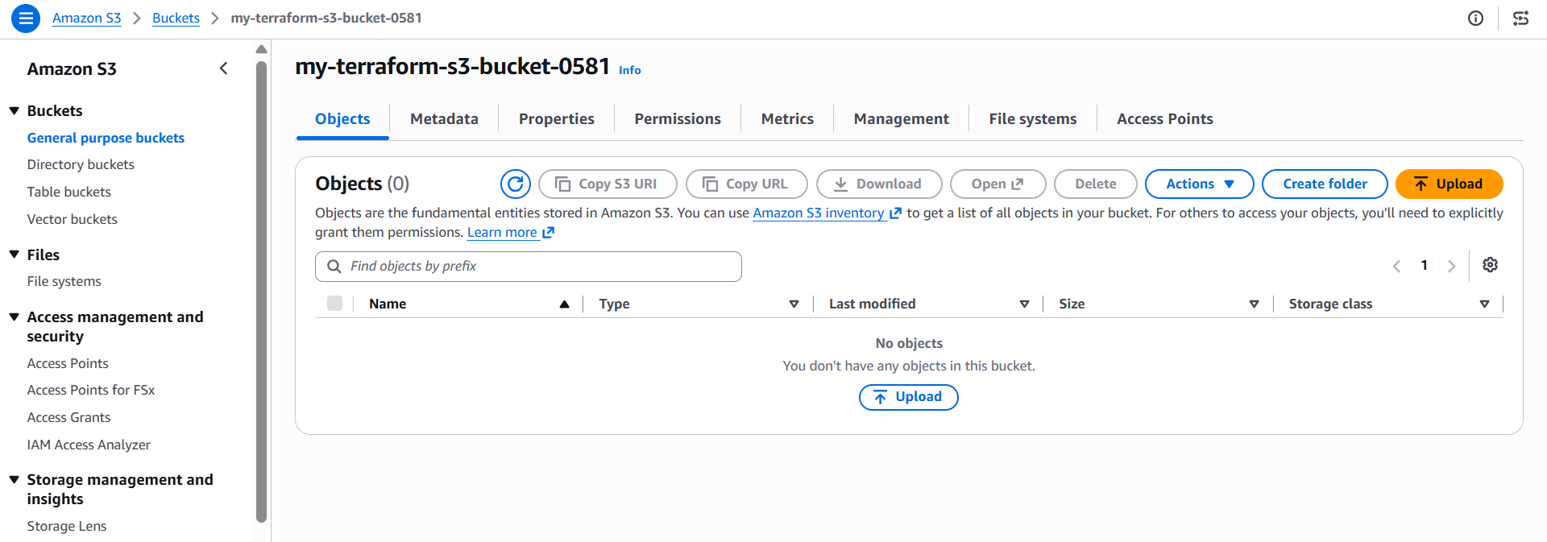
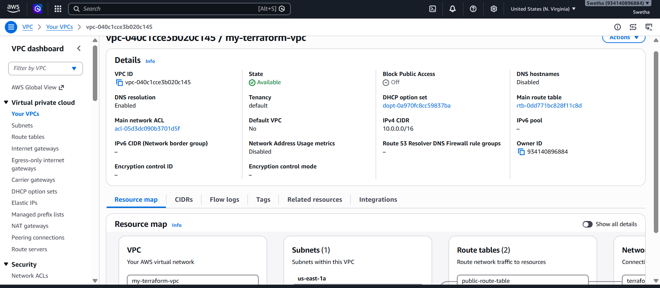
Check Terraform State
Run:
terraform state list
You should see resources similar to:
module.ec2.aws_instance.this
module.s3.aws_s3_bucket.this
module.vpc.aws_vpc.this
module.vpc.aws_subnet.public
module.vpc.aws_internet_gateway.this
module.vpc.aws_route_table.public
module.vpc.aws_route_table_association.public
This confirms that Terraform is tracking the resources in its state.
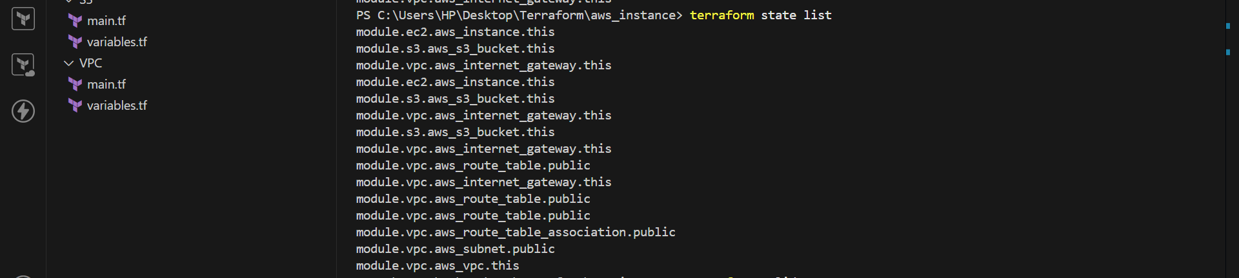
Provision EC2 for 3 different environments (Dev, Staging, and Prod) using Terraform workspaces.
The objective of this task is to provision separate EC2 instances for three different environments:
- Development — dev
- Staging — staging
- Production — prod
We use Terraform Workspaces to maintain separate Terraform state for each environment while reusing the same Terraform configuration.
Why Terraform Workspaces?
Terraform Workspaces allow us to use the same Terraform configuration for multiple environments while maintaining a separate state for each environment.
For example:
dev → dev-ec2
staging → staging-ec2
prod → prod-ec2
We don't need three separate Terraform configuration directories for this task.
Directory Structure
Create one directory for this task:
C:\Users\HP\Desktop\Terraform\workspace-ec2
Inside it, create:
workspace-ec2
│
├── main.tf
└── variables.tf
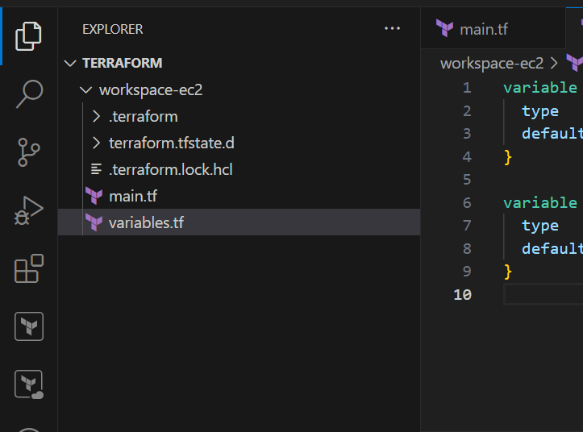
Create main.tf
Open main.tf and add:
provider "aws" {
region = "us-east-1"
}

resource "aws_instance" "server" {
ami = var.ami_id
instance_type = var.instance_type

tags = {
Name = "${terraform.workspace}-ec2"
Environment = terraform.workspace
}
}
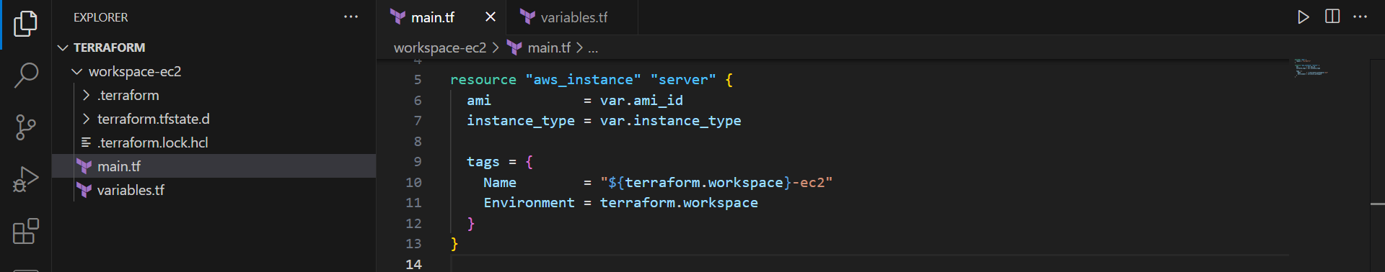
Create variables.tf
Create variables.tf:
variable "ami_id" {
type = string
default = "ami-0332d564d76dbd8d6"
}
variable "instance_type" {
type = string
default = "t3.micro"
}
Here:
ami_id → AMI used to launch the EC2
instance_type → EC2 instance size
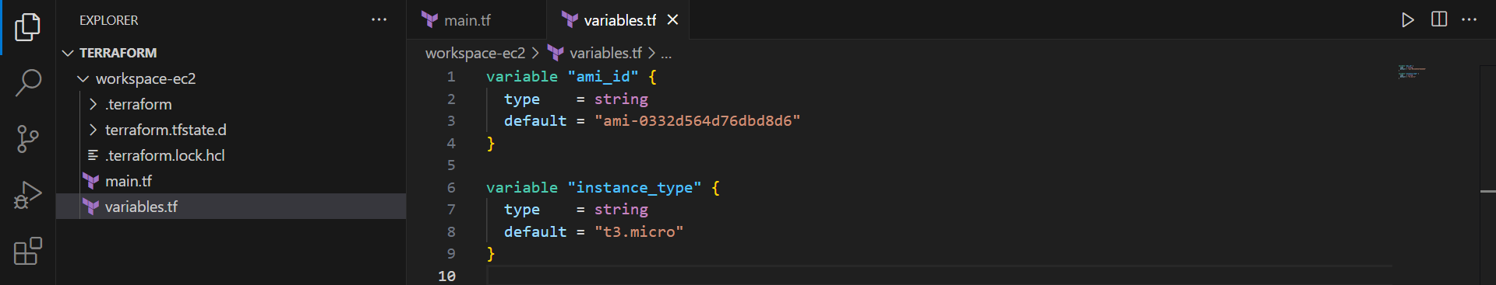
Initialize Terraform
Go to the project directory:
cd C:\Users\HP\Desktop\Terraform\workspace-ec2
Run:
terraform init
This initializes the Terraform working directory and downloads the AWS provider.
Expected result:
Terraform has been successfully initialized!
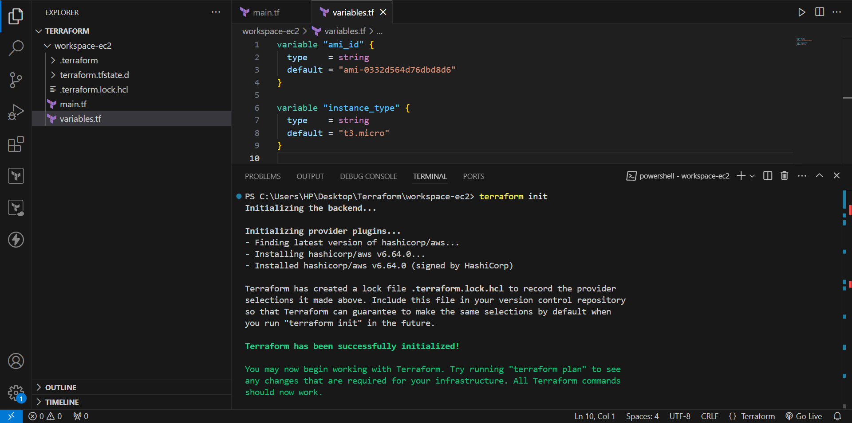
Create Terraform Workspaces
Create the Development workspace:
terraform workspace new dev
Create the Staging workspace:
terraform workspace new staging
Create the Production workspace:
terraform workspace new prod
Terraform switches to the newly created workspace automatically.
Check Available Workspaces
Run:
terraform workspace list
You should see:
default
dev
staging
* prod
The * indicates the currently selected workspace.
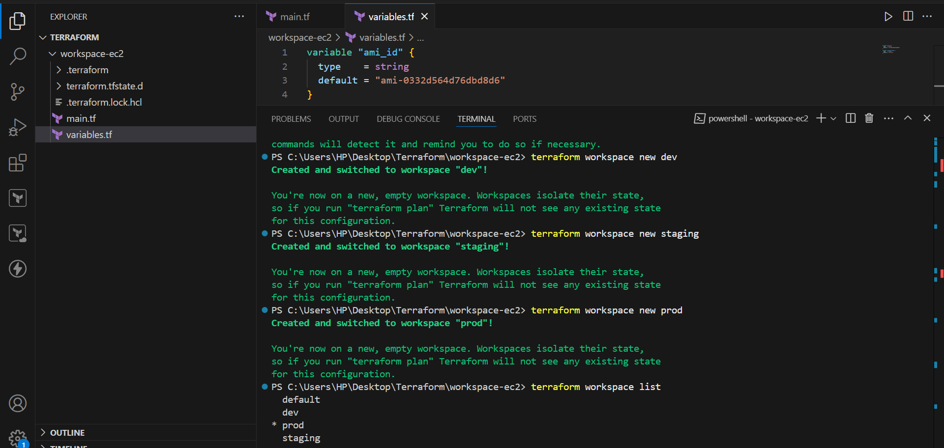
Switch to Dev Workspace
Switch to the Development workspace:
terraform workspace select dev
Verify:
terraform workspace show
Expected:
dev

11. Create Dev EC2
Run:
terraform plan
Terraform should show:
Plan: 1 to add, 0 to change, 0 to destroy.
Apply the configuration:
terraform apply
Enter:
yes
Terraform creates the EC2 instance.
The EC2 will have:
Name = dev-ec2
Environment = dev
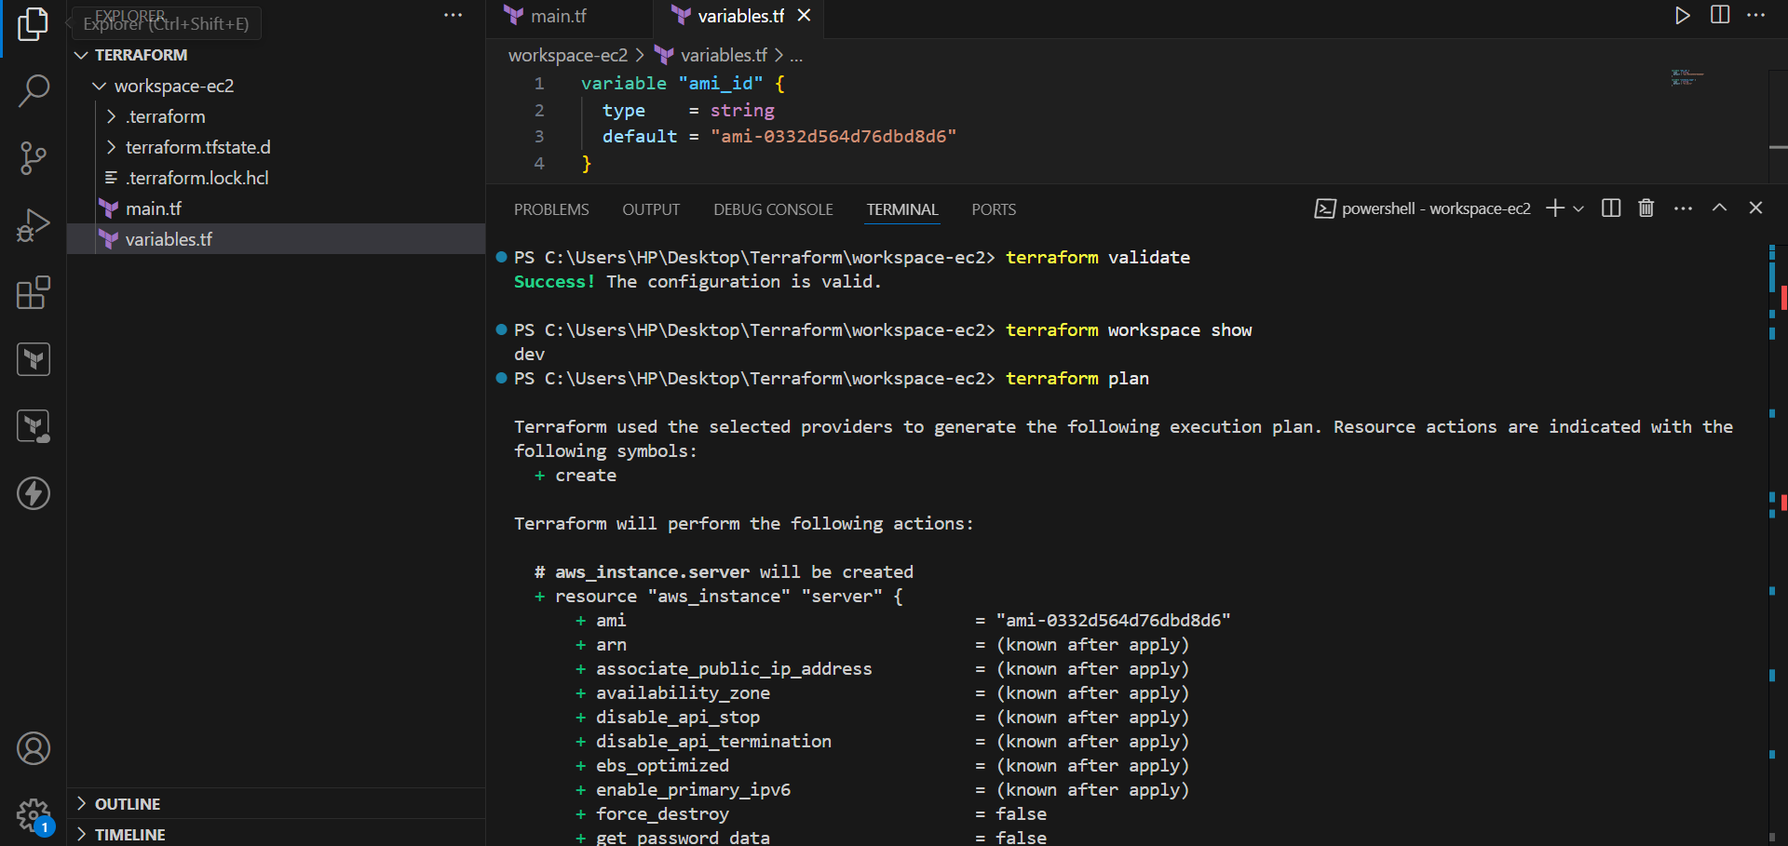
Verify Dev Resource
Run:
terraform state list
Expected:
aws_instance.server
The resource is now stored in the dev workspace state.
Switch to Staging Workspace
Now switch from Dev to Staging:
terraform workspace select staging
Verify:
terraform workspace show
Expected:
staging

14. Create Staging EC2
Run:
terraform plan
Terraform will show a new EC2 because the staging workspace has its own separate state.
Then run:
terraform apply
Enter:
yes
Terraform creates:
staging-ec2
with:
Name = staging-ec2
Environment = staging

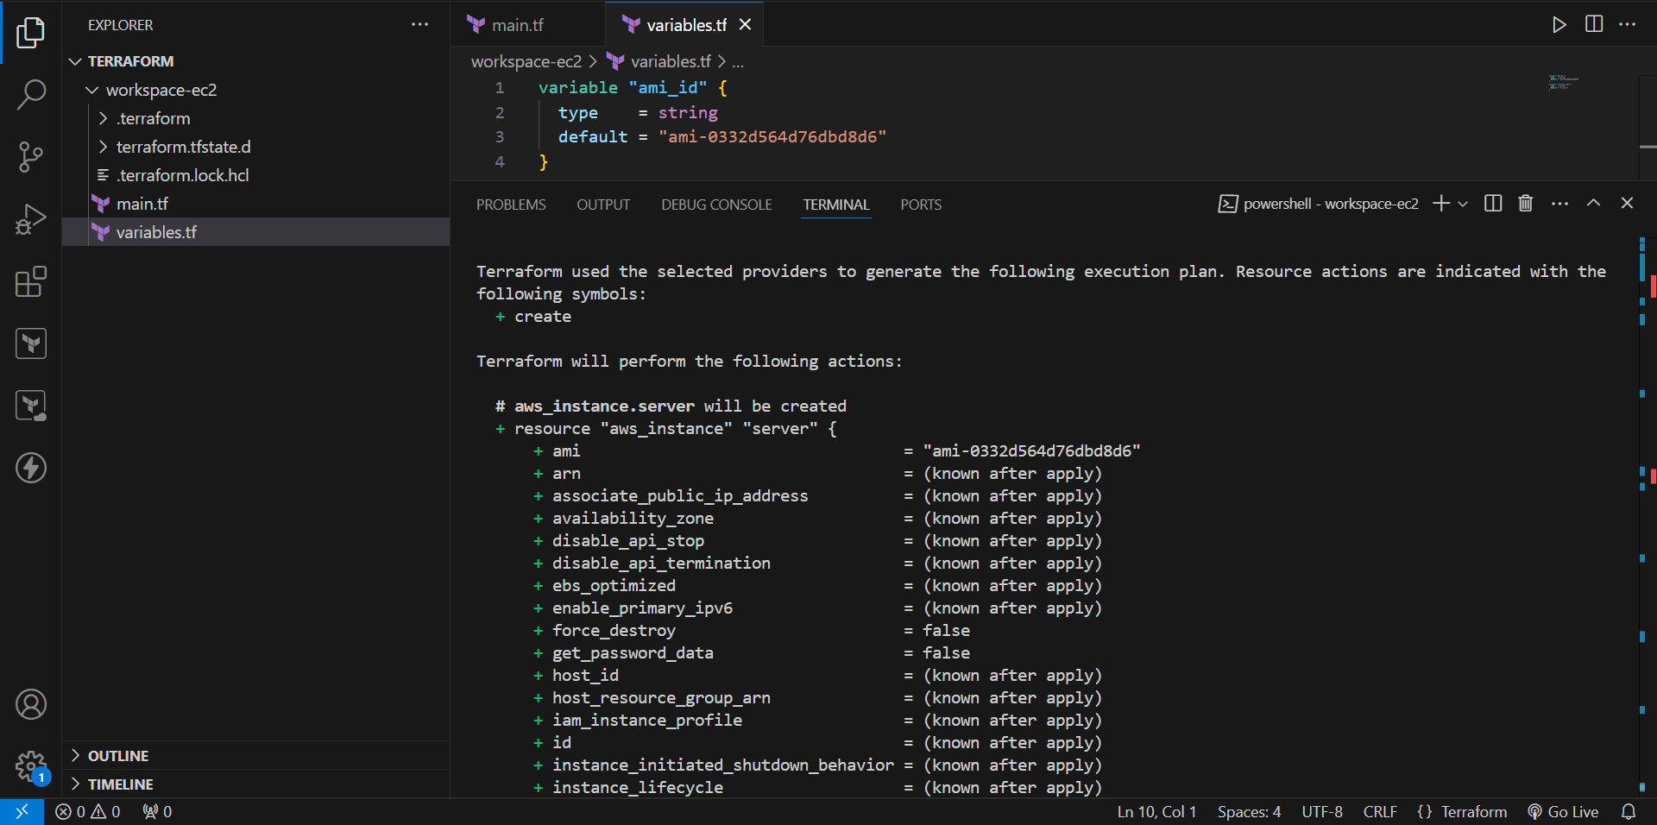
Switch to Prod Workspace
Switch to Production:
terraform workspace select prod
Verify:
terraform workspace show
Expected:
prod

16. Create Prod EC2
Run:
terraform plan
Then:
terraform apply
Enter:
yes
Terraform creates:
prod-ec2
with:
Name = prod-ec2
Environment = prod
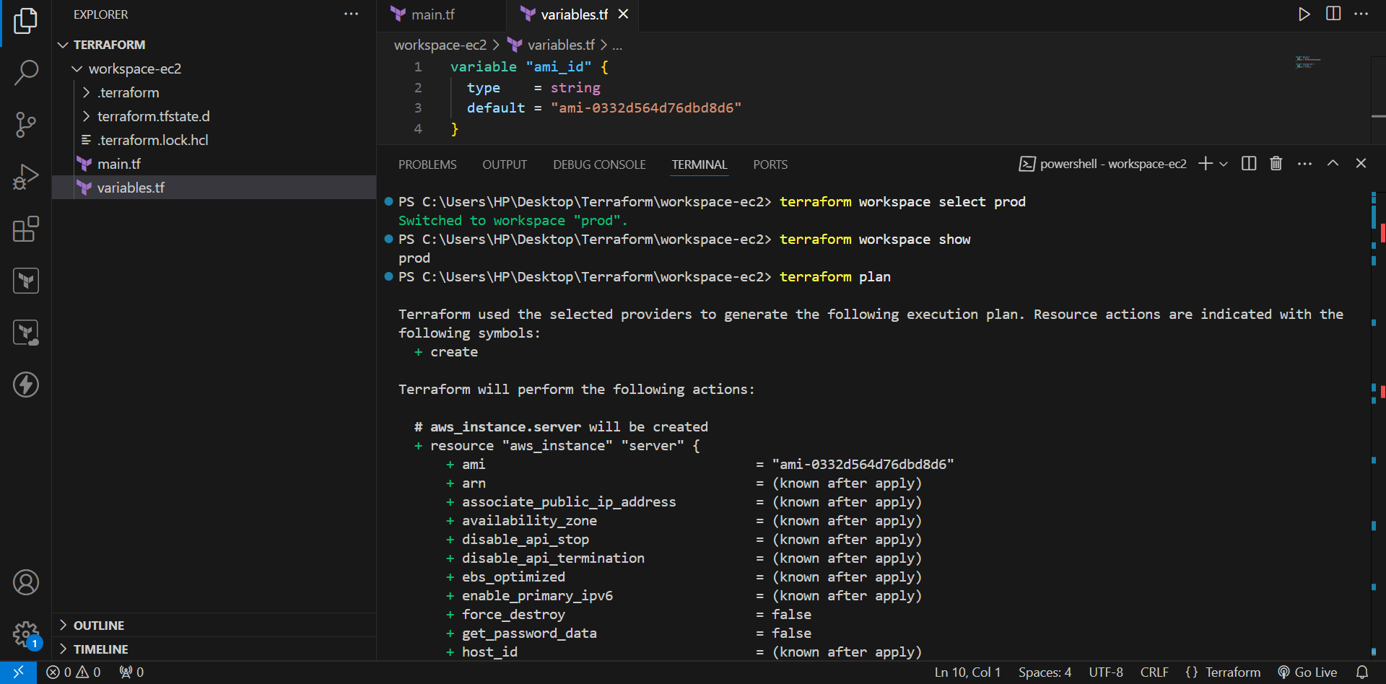
Final Workspace Verification
Run:
terraform workspace list
Expected:
default
dev
staging
* prod
The * shows that the current workspace is prod.

18. Final AWS Result
After completing all three environments, the AWS EC2 console should contain:
Environment | EC2 Instance Name
Dev | dev-ec2
Staging | staging-ec2
Prod | prod-ec2
The same Terraform code is reused for all three environments.
